Contents

1 Introduction: 1

2 Differences: 1

3 Comparison of Class Environment: 2

3.1 The Grammar Translation Method: 2

3.2 The Direct Method: 3

4 Compatibility of GTM and DT: 4

5 Conclusion: 5

# Introduction:

Direct Method and Grammar Translation Method are the two oldest methods for teaching foreign languages. Grammar Translation Method first appeared in the 18th century and was originally used for teaching old languages like Greek, Latin then failed in teaching communication skills. After that, Direct Method was built with the attempts to overcome the weakness of the Grammar Translation Method. As a result of that, there are many differences in the principles of these two methods.

# Differences:

The first and foremost difference between the Direct Method and The Grammar Translation method is the goals of the teachers using them. In Grammar translation Method, the teachers’ fundamental purpose is to help the students read and appreciate literature written in the target language. To be able to do this students have to learn a lot about the grammar rules and vocabularies. On the contrary, the teachers who use the Direct Method intend that the students learn how to communicate in the target language. It is very important that the students are believed to think in the target language.

In addition, due to the different teaching goals, there is a great disparity in teaching and learning process of the Grammar Translation Method and the Direct Method. In a typical Grammar Translation Method class, students are taught to translate from one language to another. They are also asked to memorize the native language equivalents for the target language vocabulary words. In contrast, the native language should not be used in the classroom. The students need to associate the meaning and the target language directly. To help the students to do this, the teacher demonstrates the meanings through pictures, realia, or pantomime. In other words, translation is never used in this type of class.

# Comparison of Class Environment:

## The Grammar Translation Method:

The Grammar translation method or classical method emerged when people of the western world wanted to learn "foreign" languages such as Latin and Greek. Its focus was on grammatical rules, the memorization of vocabulary and of various declensions and conjugations, translations of texts, doing written exercises.

A class working with the Grammar translation Method would look like that:

1. Classes are taught in the mother tongue, with little active use of the target language.

2. Much vocabulary is taught in the form of lists of isolated words.

3. Long elaborate explanations of the intricacies of grammar are given

4. Grammar provides the rule for putting words together, and instruction often focuses on the form and inflection of words.

5. Reading of difficult classical texts is begun early.

6. Little attention is paid to the content of texts, which are treated as exercises in grammatical analysis.

## The Direct Method:

The basic premise of the Direct Method was that second language learning should be more like first language learning. The method would include lots of oral interaction, spontaneous use of language, no translation between first and second languages, and little or no analysis of grammar rules.

Here are the principles of the direct method:

1. Classroom instruction was conducted exclusively in the target language.

2. Only everyday vocabulary and sentences were taught.

3. Oral communication skills were built up in a carefully traded progression organized around

questions-and-answer exchanges between teachers and students in small intensive classes.

4. Grammar was taught inductively

5. New teaching points were taught through modeling and practice

6. Concrete vocabulary was taught through demonstration, objects, and pictures;

Abstract vocabulary was taught through association of ideas.

7. Both speech and listening comprehension were taught

8. Correct pronunciation and grammar were emphasized.

# Compatibility of GTM and DT:

In my opinion these methods don’t complement each other. They are different in all ways and somehow undermine each other.

Below is a chart to strengthen my statement.

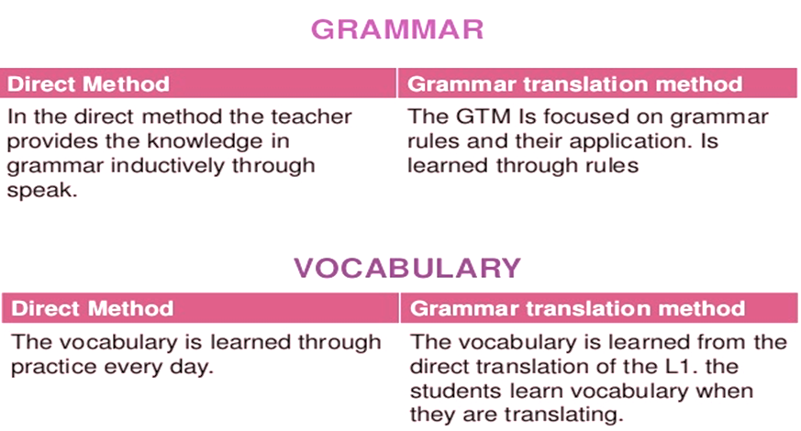

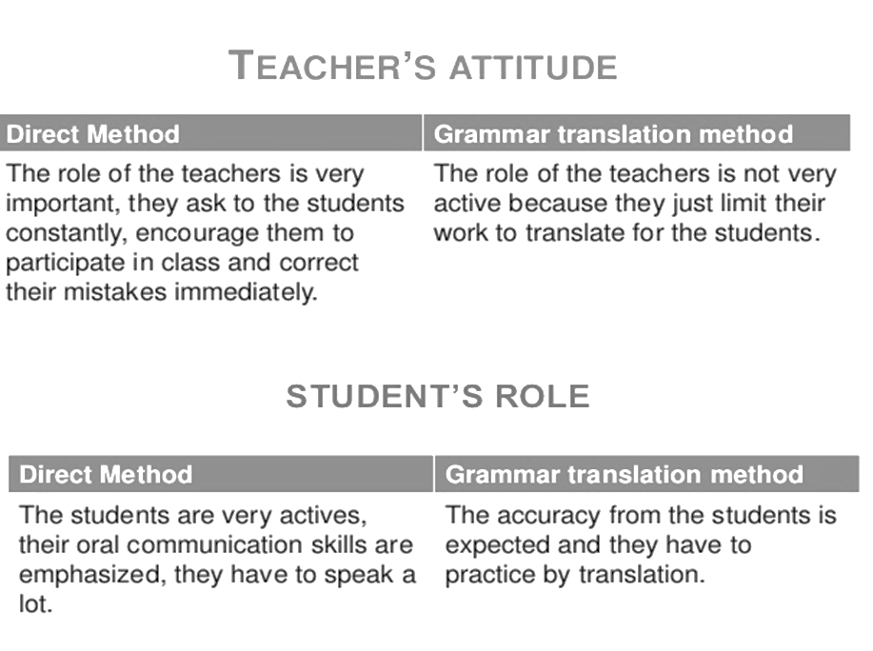

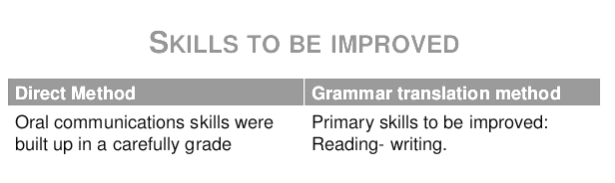

# Conclusion:

After this comparison we (as future teachers) come to know the differences of both methods. As future teacher we must know these differences in order to improve class productivity and to use the best of didactic methods. As teacher we are going to improve the knowledge of our students and at the same time we have the opportunity to experiment different types of teaching method to choose or create our own method.