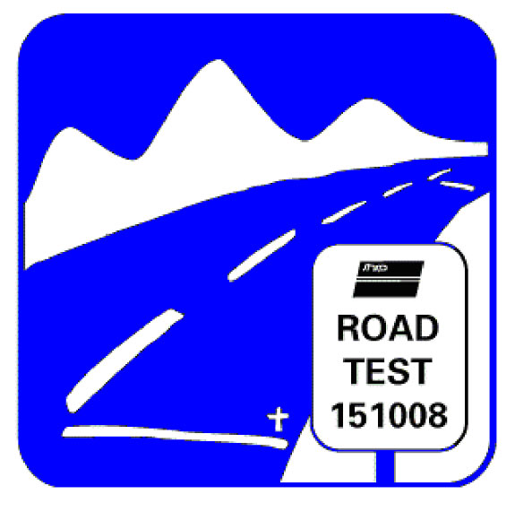

Long-Term Pavement Performance
LTPP Customer Support - FHWA, HRDI-30 - 6300 Georgetown Pike McLean, VA 22101 – Tel (202) 493-3035 – Fax (202) 493-3161
Email: LTPPInfo@dot.gov

January 11, 2011

Dear Customer,

Enclosed you will find a copy of the Long-Term Pavement Performance (LTPP) Program Standard Data Release (SDR), version 25.0, DVD and the Reference Library DVD. The SDR data is extracted from the production Pavement Performance Database (PPDB) and is divided by data module into multiple relational databases. Due to size limitations, the Falling Weight Deflectometer (FWD) and profile data tables are further subdivided by highway agency; Seasonal Monitoring Program (SMP) tables and Climate tables are separated into multiple databases for the same reason. Each data module is provided in a Microsoft ® Access 2000 database that has been zipped to save disk space. Double-click on each file and follow instructions to unzip. Contents of SDR 25.0 are listed on the back cover of the DVD set.

The Reference Library DVD contains several documents and software programs that support use of the LTPP database. They are grouped into directories as follows:
- Utility Software – The Table Navigator software, which combines the contents of the reference documents (Database Schema, Data Dictionary, and Codes List) into a searchable database.
- Resource Documents – Several important documents are in this section, including, the LTPP Data User Guide (November 2010), which provides an overview of the LTPP program and data collected; Accessing LTPP Data, which is an introduction in to using Microsoft ® Access 2000; Data Analysis/Operations Feedback Report, which provides a venue for reporting any problem(s) found in SDR 25.
- Research Reports – Reports based on the LTPP data.

For more information about the LTPP program, you may visit the LTPP Home Page by going to the web site http://www.fhwa.dot.gov/pavement/ltpp/.

If you have any questions, please feel free to contact the Customer Support Service Center at the email address ltppinfo@dot.gov.

Sincerely,

LTPP Customer Support Service Representative

